**Quit Bugging Me! The Invasive Asian Reed Scale, *Nipponclerda biwakoensis*,attacks stressed Roseau Caneon the Gulf Coast, USA**

**I. Statement of Work**

Roseau cane is a coastal native type of *Phragmites australis* (common reed) that grows along the Gulf Coast of the United States. This critically important native species is a perennial grass that provides many coastal ecosystem services such as storm buffering, sediment stabilization, water quality maintenance, and habitat for wildlife (Knight *et al*, 2018; Rodriguez and Brisson, 2015).However, roseau cane is under attack by a newly introduced insect pest known as the Asian reed scale (Fig 1, *Nipponclearda biwakoensis*). The ecosystem services provided by roseau cane to the Gulf Coast are threatened and will be lost if roseau cane succumbs to this new invasive insect.

The Gulf Coast, specifically the Mississippi River Delta (MRD), is a “hotspot” for *P. australis* genetic diversity, hosting multiple lineages and haplotypes (Knight *et al*, 2018; Lambertini *et al*, 2012). While the invasive European *P. australis*, or haplotype M,has negative consequences such as reducing biodiversity and altering nutrient cycles (Meyerson et al, 2000), the native roseau cane is critical for sediment stabilization and protecting the coast. The dense root and rhizome system of roseau cane easily traps and accumulates sediment providing erosion control in the MRD in Louisiana. 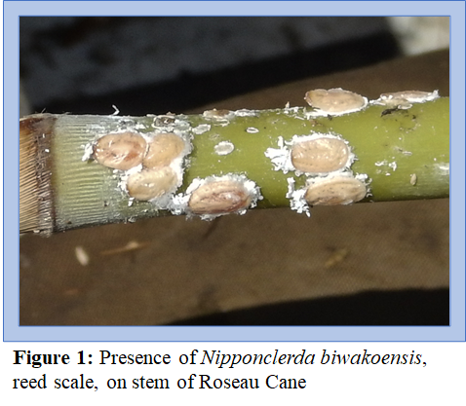

In the MRD, roseau caneis subjected to multiple natural and anthropogenic stressors such as salinity and eutrophication. In response to increasing salinity, roseau cane, like many plants, releases soluble sugars when stressed in an effort to osmoregulate (Cha-um *et al*, 2009; Ashraf and Harris, 2004; Čížková *et al*, 1996). This response has been observed in both salt tolerant and salt sensitive plants, but salt tolerant plants overall produced more soluble sugars in comparison to the sensitive varieties (Cha-um *et al*, 2009; Ashraf and Harris, 2004), indicating that the release of soluble sugars is an adaption to dealing with salinity stress. The same response was observed in *P. australis* when it was exposed to a hyper-eutrophic environment (Čížková *et al*, 1996), where carbohydrates are as a energy source by *P. australis* when low-oxygen genes activate causing carbohydrate metabolism. Studies have also shown that *P. australis* reduces starch reserves when under stress suggesting a trade-off between producing sugars for immediate stress adaptation and storage of reserves for future growth (Fogli *et al.*, 2002; Armstrong and Armstrong, 1999). When not stressed, sugars are stored as starch in the rhizomes, which are used in the spring for initial growth (Karunaratne *et al*, 2004; Graneli *et al*, 1992). 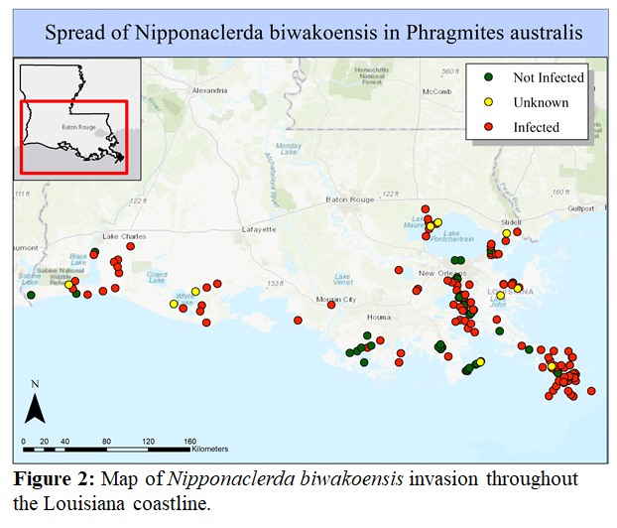

While *P. australis* can tolerate stressors such as salinity and eutrophication (Meyerson et al. 2000), a growing number of studies have reported on a phenomenon called reed dieback, which is associated with sulfide toxicity and has been observed in both Europe and North America (Lamers *et al.*, 2013; Alber *et al.*, 2008; Chambers *et al.*, 2003; Fogli *et al.*, 2002; Armstrong and Armstrong, 1999). This is catastrophic for coastal wetland regions such as the MRD in Louisiana that rely on native *P. australis*, the roseau cane, for erosion control and are facing massive ecosystem, habitat, and overall land loss. To make matters worse, as the native roseau cane dies back, it is replaced by harmful invasive plant species such as giant salvinia (*Salvinia molesta*) and water hyacinth (*Eichornia crassipes*), resulting in a phenomenon known as invasional meltdown (Simberloff and Von Holle 1999).

While investigating areas of dieback in the MRD, a newly introduced Asian reed-scale *Nipponaclerda biwakoensis* was detected(Figure 2, Knight *et al.* 2018). This introduced invasive herbivorous insect consumes the sap of native roseau cane and establishes large colonies, in some cases as much as 2,000 individuals per stem (Knight *et al.*, 2017; Kaneko, 2004). However, because this invasion was detected only two years ago, little is known about the impacts of this invasive herbivore. A window of opportunity currently exists to rapidly identify the underlying mechanisms in roseau cane physiology in response to the insect that are facilitating this invasion. Such information can help to develop and inform management solutions to protect roseau cane and the services it provides to the Gulf Coast ecosystem.

Undoubtedly, there are many environmental stressors contributing to the dieback of roseau cane in the MRD, with some studies attributing the phenomena to conditions such as high concentrations of sulfides and eutrophication. While all of these conditions are stressful, *P. australis* can ameliorate these stressors by producing and allocating synthases such as soluble sugars (Figure 3). For example, the rhizomes of *P. australis* can survive anoxic conditions for several weeks provided that they have enough starch in reserve (Čížková *et al.* 1996). However, the ability of plants to respond when reserves are depleted by an invasive novel herbivore is likely diminished and may cause plants to succumb to environmental stressors that they would otherwise tolerate.

My hypothesis that the invasive reed scale is reducing the ability of roseau cane to tolerate stressful environmental conditions by removing soluble sugars normally used for osmoregulation. As a result, roseau can has fewer resources to dedicate to starch reserves for the following growing season and productivity of roseau cane declines. The loss of defenses renders roseau cane more vulnerable to the stressors that it could previously tolerate leading to reed die in areas infected by the invasive reed scale. This study will: **1)** Compare soluble sugar concentrations and starch reserves between patches with and without reed scale, **2)** Determine if there is a relationship between roseau cane mortality and density of colonization by reed scale, **3**) Determine if there a relationship between environmental conditions (salinity, eutrophication) and the infestation of reed scale. **4)** Determine if resistance to reed scale is related to lineage. 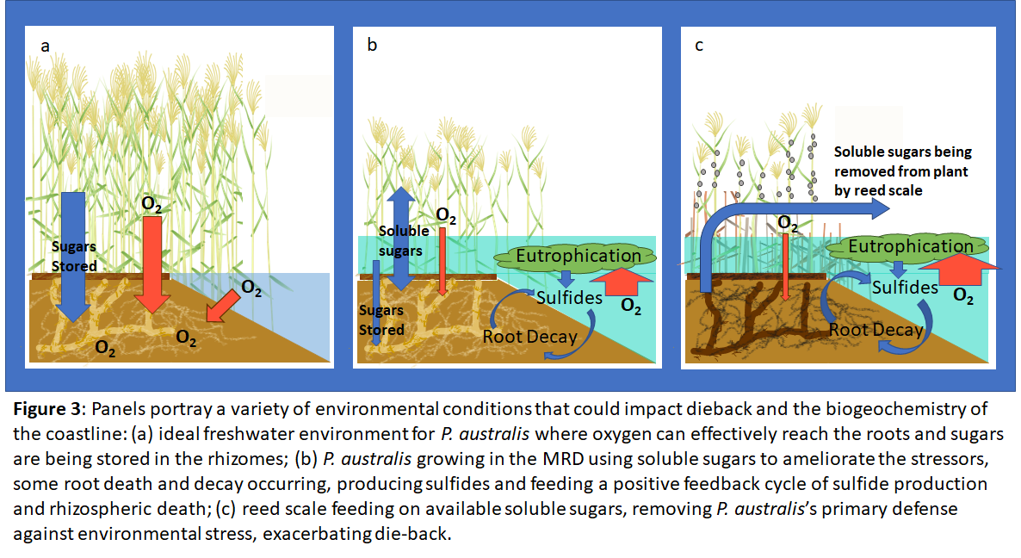

**Research Questions:**

1. Does the decline in starch reserves and the production of soluble sugars vary with haplotype, the presence of the reed scale, and environmental conditions (salinity, DO)?
2. Is there a relationship between the density of reed scale on stems of roseau cane environmental conditions? In other words, do population numbers of reed scale increase on roseau cane where salinity is higher or DO is lower?)
3. Is survivability of the patch relative to lineage?

**Methods:**

Field: I will travel to Louisiana to collect samples in both the early summer and in late autumn to collect plant tissues (rhizome, stem, leaf) at the start and end of the growing season. I will collect samples from infested and non-infested sites and count individual reed scale density in infested sites. I will establish 12 field sites in both reed scale infested and non-infested areas. The two time periods (spring and fall) are necessary to quantify differences in soluble sugars and starch reserves over the growing season. I will run transects in each site counting living and dead stems. I will collect two rhizome cores (15 cm x 30 cm) and three stems from each plot to analyze for sugars and starches. Cores will be rinsed with DI water to separate out dead and living rhizomes and roots, and these will be dried and weighed. The reed scale on stems will be counted before being collected, stem rinsed and cut into sections. Plant tissues, with the exception of rhizomes, will be rinsed and kept on ice in the field, then oven dried in the lab prior later analysis for starches and soluble sugars, respectively. Dried samples will be kept with silica pellets and transported from Louisiana to Rhode Island and processed in the Meyerson Lab at URI. Rhizomes will be wrapped in wet paper towel and stored in 4 C refrigerator until transport.

Sample Analysis: Starch reserves will be analyzed by cutting and iodine staining rhizome internodes (Armstrong & Armstrong, 1999; Fogli *et al*, 2002; Reale *et al*, 2012). Samples will be placed under a microscope in the URI GSC and photographed. Starch reserves (% cover) will be quantified using ImageJ (Reale *et al*, 2012) and compared over two time intervals to quantify starch concentration change. Carbohydrates and starches will be extracted from plant tissues from both rhizome and leaves according to the methods of Tang *et al* (2014) and quantified using a colorimetric method for microplates (Hendrix, 1993; Morris 1948). Leaf samples will also be ground and processed using a plant DNA extraction kit to determine lineage of each sample.

**II. What portions of the work have been completed?**

This grant proposal offers the opportunity to expand on my current work to better understand the interactions of environmental stressors and invasion that are leading to roseau cane dieback in the Gulf. Based on data shared with me by the Louisiana State University collaborative, I have completed GIS maps (Figure 2) of the sample sites which identify reed scale-infested and non-infested sites of *P. australis*. Using dried tissues collected at all of these sites, I have initiated DNA extractions for genetic analysis of plant tissue to determine plant lineage and haplotypes at all sites (Figure 2). This work will be completed in the next three months. Once haplotyping is complete, I will select three sites for each haplotype in infested areas and three sites for each haplotype in uninfested areas (total of 24 sites). These are the sites that I will travel to to collect samples and conduct analyses (see section on Methods).

**III. How the study benefits coastal wetlands**

It is well-known that coastal wetlands provide critical buffers to storm damage and that storm intensity and frequency is expected to increase under climate change. Coastal marshes also help to mitigate sea-level rise through marsh accretion and by slowing erosion. The loss of coastal marshes means that the impacts associated with climate change and sea-level rise will be even more severe. This study will benefit coastal wetlands in a number of ways. First, understanding the mechanisms of stress tolerance in *P. australis* with regards to soluble sugars will provide an opportunity to develop more targeted management solutions. Second, this work will identify some of the mechanisms that facilitate herbivory and exacerbate die-back also providing information to develop management interventions for the invasive reed scale. Since the invasion by the reed scale is recent, a window of opportunity exists to understand to what degree this invasive herbivore is affecting *P. australis*, particularly roseau cane, and develop management plans to minimize damage to roseau cane. Finally, most *P. australis* is in the Gulf is roseau cane, the introduced European genotype is also invading and may be more tolerant of the invasive reed scale than native roseau cane thereby further contributing to invasional meltdown in the region.

**IV. How funds will be used**

*Travel*: Airfare to Louisiana to conduct field week long surveys and gather data, lodging, car rental ($400, per round trip ticket, total airfare = $800; $350/week lodging, $225/week board, total lodging and board for two visits = $1150; Field vehicle provided by LSU. Total travel costs for two field visits = $1950.

*Field Supplies*: PVC tubing to make quadrats, plastic bags to collect samples, PVC cutters (to cut plant samples and PVC tubing), ice, markers, field notebooks, GPS $250.

*Lab supplies:* Iodine stain for starch analysis, liquid N, microcentrifuge tubes, DNA extraction kit, tips, gloves, $800.

*Sample Analysis*: Approximately 400 samples (including replicates and re-runs) analyzed for sugars using microplating method ($1500). Supplies (Slides, covers, stain, razors) and rental time on microscope ($500).

*Total request is $5000*.

**IV. Plans or opportunities for sharing research with a larger audience**

I will publish the results of this research in a peer review journal such as *Rhodora* or *Biological Invasions* and give presentations at regional and international conferences such as the Ecological Society of America annual meeting. I will share my results with other Phragmites research groups such as the LSU die-back collaborative ([LSUAgCenter](https://www.lsuagcenter.com/topics/environment/invasive%20species/roseau%20cane%20die-off)), the [Great Lakes Phragmites Collaborative](https://www.greatlakesphragmites.net/) ), and [PhragNet](http://academic.sun.ac.za/cib/news/2017/0117_global_network_progress.htm). At URI I will share this research by training undergraduates both in the lab and field, presenting results in in invasion and restoration ecology classes, and the URI Graduate student colloquium. In addition, I will work with the URI communications office to produce press releases to reach out to the media to convey the importance of the Roseau Cane and inform the public about the consequences of marsh degradation.

**References**

Alber, M., E. Swenson, S. Adamowicz, I. Mendlessohn. (2008) “Salt Marsh Dieback: An Overview of Recent Events in the US.” *Estuarine, Coastal and Shelf Science* 80: 1–11.

Armstrong, J., and W. Armstrong. (1999) “Phragmites die-Back: Toxic Effects of Propionic, Butyric and Caproic Acids in Relation to PH.” *New Phytologist* 142:201–217.

Ashraf, M., and P.J.C. Harris. (2004) “Potential Biochemical Indicators of Salinity Tolerance in Plants.” *Plant Science*, vol. 166: 3–16.

Čížková, H., *et al*. (1996) “Carbohydrate Levels in Rhizomes of *Phragmites australis* at an Oligotrophic and a Eutrophic Site: A Preliminary Study.” *Folia Geobotanica Et Phytotaxonomica* 31: 111–118.

Chambers, R., D. Osgood, D. Bart, F. Montalto. (2003) “*Phragmites australis* Invasion and Expansion in Tidal Wetlands: Interactions among Salinity, Sulfide, and Hydrology.” *Estuaries* 26:398–406.

Cha-Um, S., *et al*. (2009) “Sugar Accumulation, Photosynthesis and Growth of Two Indica Rice Varieties in Response to Salt Stress.” *Acta Physiologiae Plantarum* 3: 477–486.

Fogli, S, et al. (2002) “Reed (*Phragmites australis*) Decline in a Brackish Wetland in Italy.” *Marine Environmental Research* 53: 465–479.

Graneli, Wilhelm, et al. (1992) “Rhizome Dynamics and Resource Storage in *Phragmites australis*.” *Wetlands Ecology and Management* 1: 239-247.

Hartzendorf, T. and Rolletschek, H. (2001) “Effects of NaCl-Salinity on Amino Acid and Carbohydrate Contents of *Phragmites austral*is.” *Aquatic Botany* 69:195–208.

Hendrix, D. (1993) “Rapid Extraction and Analysis of Nonstructural Carbohydrates in Plant Tissues.” *Crop Science*, vol. 33: 1306.

Kaneko, S. (2004) “Within-Plant Vertical Distributions of the Scale Insect *Nipponaclerda Biwakoensis* and Its Five Parasitoids That Exhibit Frequent Successful Multiparasitism on the Common Reed.” *Entomological Science*, 7: 331–339.

Knight, I., *et al*. (2018) “Invasion of *Nipponaclerda biwakoensis* (Hemiptera: Aclerdidae) and *Phragmites australis* Die-Back in Southern Louisiana, USA.” *Biological Invasions*, 20: 2739–2744.

Karkacier, M., *et al.* (2003) “Comparison of Different Extraction and Detection Methods for Sugars Using Amino-Bonded Phase HPLC.” *Journal of Chromatographic Science*, vol. 41: 331–333.

Karunaratne, S., *et al.* (2004) “Shoot Regrowth and Age-Specific Rhizome Storage Dynamics of *Phragmites australis* Subjected to Summer Harvesting.” *Ecological Engineering*, vol. 22: 99–111.

Lamers, L., *et al.* (2013) “Sulfide as a Soil Phytotoxin—a Review.” *Frontiers in Plant Science*, 4: 1-14.

Lambertini, C., *et al.* (2012) “Tracing the Origin of Gulf Coast *Phragmites* (Poaceae): A Story of Long-Distance Dispersal and Hybridization.” *American Journal of Botany*, vol. 99: 538–551.

Meyerson, L., K. Saltonstall, L. Windham, E. Kiviat, and S. Findlay. (2000) A Comparison of *Phragmites australis* in freshwater and brackish marsh environments in North America. Wetlands Ecology and Management 8: 89-103.

Morris, D. (1948) “Quantitative Determination of Carbohydrates With Dreywood's Anthrone Reagent.” *Science*, vol. 107: 254–255.

Reale, L., *et al*. (2012) “Morphological and Histo-Anatomical Traits Reflect Die-Back in *Phragmites australis* (Cav.) Steud.” *Aquatic Botany* 103:122–128.

Rodríguez, M., and J. Brisson. (2015) “Pollutant Removal Efficiency of Native versus Exotic Common Reed (*Phragmites australis*) in North American Treatment Wetlands.” *Ecological Engineering* 74:364–370.

Simberloff, D. and Von Holle, B. (1999) “Positive interactions of nonindigenous species: Invasional meltdown?” *Biological Invasions*, 1: 21.

Tang, F., *et al*. (2014) “Carbohydrate Profiles during Cotton (Gossypium Hirsutum L.) Boll Development and Their Relationships to Boll Characters.” *Field Crops Research*, vol. 164: 98–106.

Xiangbin, Gao, *et al*. (2012) “Response of Cotton Fiber Quality to the Carbohydrates in the Leaf Subtending the Cotton Boll.” *Journal of Plant Nutrition and Soil Science*, vol. 175: 152–160.

Zhao, D. and Oosterhuis, D. (1998) “Cotton Responses to Shade at Different Growth Stages: Nonstructural Carbohydrate Composition.” *Crop Science*, vol. 38: 1196.